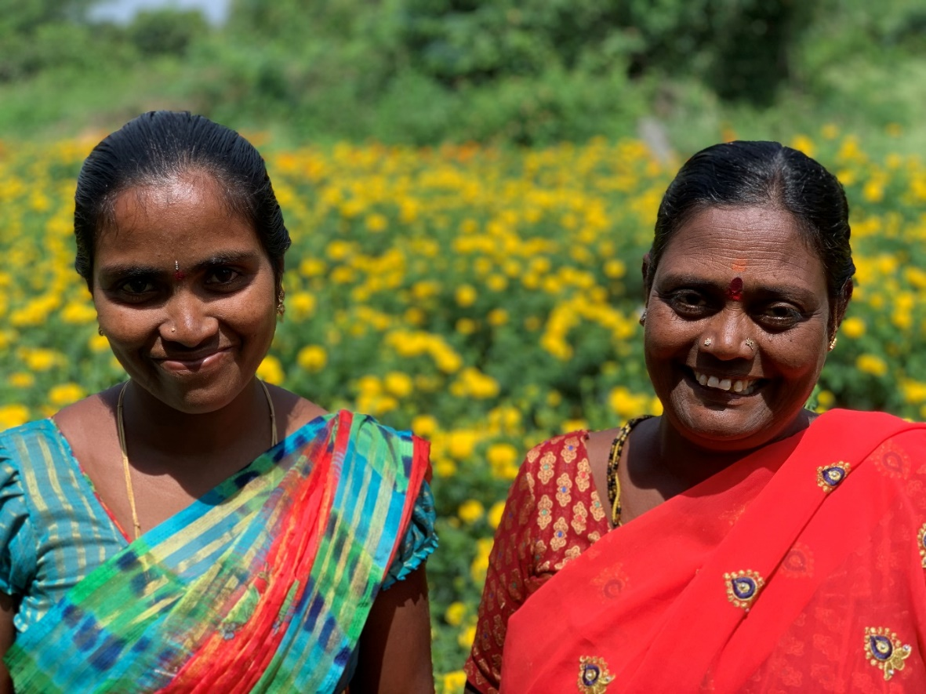
Two smallholder farmers, project RACE, Dharmaram village, Telangana (Picture: Janne Roux,
October 2022).
- This picture serves as example. Feel free to add one (incl. description), but it’s not a must.
India: Project title

Projectnumber | xx/xx
Partnerorganisation | xy
Project responsible | name, surname, E-Mail
Total budget | INR X’XXX’XXX
Project duration | DD.MM.YYYY - DD.MM.YYYY
Reporting period | DD.MM.YYYY - DD.MM.YYYY
Specific objectives (outcome) | dljfdkfjdkfkd dkfjdkf dkfjdk d kdf jdkf dkfjdkfd dkfjdkfj d kdfjdf df fkdfjdkf d kfkd dkfjdkf dkfjdk d kdf jdkf dkfjdkfd dkfjdkfj d kdfjdf df fkdfjdkf
Beneficiaries/ target group(s) | fdfdff kfkd dkfjdkf dkfjdkf d kdf jdkf dkfjdkfd dkfjdkfj d kdfjdf df fkdfjdkf d

Project context and stakeholders (1 page max)
Explain significant changes that occurred in the context since the last report and the effect these changes had on the programme.

Project key results (2 pages max)
Summarise the progress made towards desired results in the reporting period. Focus on notable over- and under-achievement and explain why these occurred. Where possible, provide specific examples to show how the project contributed to changes in beneficiaries’ lives and describe unintended positive and negative results that occurred.
- Challenges and risks (½ page max)
Explain how expected and unexpected risks affected the programme during the reporting period. Comment on actions taken to manage risks and significant new risks that you identified.

- Lessons Learned (½ page max)
Lessons learned from the reporting period and the actions taken to overcome challenges, capitalise on good practices, or use observations to improve project activities. Briefly explain how you elicited and managed lessons learned during the reporting period.

Way forward/ Next steps (½ page max)
Give an overview of the plans for the next reporting period, with reference to the proposal. If applicable, explain changes/modifications in comparison to the plans (e.g., in activities, timeline, targets, etc.).

- Financial statement (some sentences)
Explain the actual expenditure in comparison to the budget and explain significant over- and under-spending.

Annexes
- Please use the SLCW templates available when preparing the Annexes.

- Detailed financial report:
- Ideally in Excel format, but not a must.
- It can be submitted independently of the audit report.

- Audit report
- If already available at the time of submission of narrative report. If not, please note when to be expected under chapter 6 “Financial Statement”.

- Logical Framework Report:
- Not a must to submit it.

- Pictures

- Please integrate the pictures directly into the report above at the respective activities, or separately at the end of the report.
- They should always have a caption (What do we see, where (region and village), who took the picture and when?);
  - In addition, it is important for the SLCW to receive the images also separately as jpeg. Please send them either by email (if possible), or by wetransfer (https://wetransfer.com/explore/file-sharing). This is free of charge and very easy to use. It also does not take up any storage space.
  - Note: Please do not use Whats App as the quality is not good enough!

- Case Story/stories (0.5 pages max. per story incl. picture)
- How did the project activities change the lives of the persons interviewed, what are positive and/or negative impacts.
- Please take a portrait picture of the person, note name, age, location etc.

- Other documents if you have anything relevant to share

